**LIVER TUMOR SEGMENTATION USING DEEP LEARNING**

**A S SAI THEJASWINI**

**CONTENTS**

1. **INTRODUCTION TO LIVER TUMOR SEGMENTATION**
2. **TRADITIONAL METHODS OF SEGMENTATION**
3. **METHODOLOGY USING DEEP LEARNING**
4. **PRE-PROCESSING TECHNIQUES**
5. **MODELS FOR THE SEGMENTATION PROCESS**
6. **MODEL TRAINING AND SEGMENTING**
7. **POST - PROCESSING TECHNIQUES**
8. **SEGMENTED LIVER TUMOR IMAGE**
9. **CONCLUSION**

**INTRODUCTION**

Segmentation refers to the delineating the organs on the CT and MRI images.The liver is one of the most difficult organs to segment due to its highly variable shape and close proximity to other organs.Liver tumor segmentation is a crucial task in medical imaging, where the goal is to identify and delineate tumors within liver image.Liver tumor segmentation allows us to automatically categorize and classify liver tumors within these images.Since the deep learning model learn relevant features from the data, handles missing data and generalizes well.**2D Segmentation:** This approach focuses on segmenting liver tumors in two dimensions (2D). It involves identifying tumor boundaries within individual slices of medical images.· The 2D segmentation method analyzes and segments the single slice of an image, focuses on the each pixels classifier and segments the liver tumor in the two dimensional.**3D Segmentation (Volumetric Segmentation):** In contrast, the volumetric approach tackles tumor segmentation in three dimensions.With 3D image segmentation, data acquired from 3D imaging modalities such as Computed Tomography (CT), Micro-Computed Tomography (micro-CT or X-ray) or Magnetic Resonance Imaging (MRI) scanners is labelled to isolate regions of interest. These regions represent any subject or sub-region within the scan that will later be scrutinized. This could facilitate analysis of part of the human body, or a specific feature within an industrial component or assembly.Deep learning models When applied to tumor segmentation, they can achieve remarkable accuracy.Automated tumor segmentation using deep learning significantly reduces the time spent on manual delineation by radiologists.

**TRADITIONAL METHOD OF SEGMENTATION**

Traditional approaches to image segmentation include thresholding, edge detection, region growing, and watershed transforms. These methods rely on color, intensity, and texture features to segment the image. However, they often fail to produce accurate segmentation results due to complex backgrounds, varying lighting conditions, and overlapping objects.traditional approaches can effectively differentiate fabrics and materials through texture analysis but struggle in differentiating similar-colored items, like a stack of blue jeans, or within a product category, like colored shirts, and the impact of varying lighting conditions that alter the perceived texture. Intensity-based methods are designed to identify objects based on brightness contrast with the background but have limitations in cluttered settings where products blend in.Traditional methods provide a fundamental solution for product selection, but real-world scenarios demand advanced techniques like the Segment Anything Model (SAM), which accurately segments objects in complex environments, enabling precise and reliable product identification. This enhances the overall efficiency and effectiveness of the selection process.

**METHODOLOGY USING DEEP LEARNING**

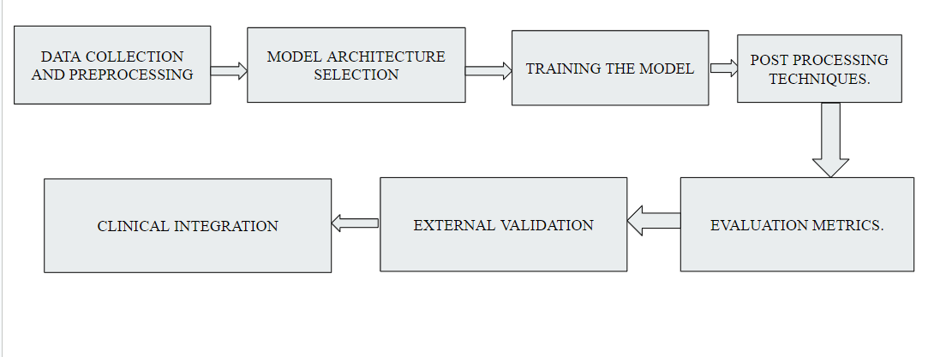

The deep learning technique for image segmentation uses methods like data collection and pre-processing. Selection of the model and training the mode. Applying the post-processing techniques and calculating the evaluation metrics.And validating

**PRE-PROCESSING TECHNIQUES**

1. **IMAGE NORMALIZATION:**

Adjust intensity values across different scans to standardize the images.

The intensity is normalized to standardize the image using methods like Histogram equalization and Auto normalization.

1. **DENOISING:**

Image denoising is the process of removing unwanted noise from an image, enhancing its quality and making it more visually appealing.

Spatial Filtering (Traditional Methods) – MEDIAN FILTER

(WORK OF SPATIAL FILTERING : REPLACES THE EACH PIXELS WITH THE MEDIAN VALUE IN ITS NEIGHBORHOOD)

1. **RESAMPLING:**

Change the resolution of the image to achieve isotropic voxels, ensuring uniformity across slices for consistent analysis.

Resampling is a process used in various fields, particularly in digital signal processing and image processing, to change the sample rate or resolution of a signal or image. This can involve either increasing or decreasing the number of samples or pixels.

1. **CONTRAST ENHANCEMENT**

Contrast enhancement is a technique used in various fields, such as image processing, photography, and medical imaging, to improve the visibility of features in an image. By increasing the difference between light and dark areas, contrast enhancement can make objects more distinguishable and improve overall image clarity.

**MODELS OF THE SEGMENTATION PROCESS**

* **CONVOLUTIONAL NEURAL NETWORKS:**

The backbone of segmentation tasks.

* **U-NET :**

A popular architecture for biomedical image segmentation, featuring an encoder-decoder structure that captures context and precise localization.

* **3D CNNs**:

Used for volumetric data, enabling the model to process multiple slices simultaneously.

* **ATTENTION MECHANISMS**:

These can be integrated to allow the model to focus on relevant features, enhancing segmentation accuracy.

* **RESNET AND VARIANTS:**

Residual Networks (ResNet) can be adapted for segmentation tasks

* **DEEPLAB:**

Employs atrous (dilated) convolutions to capture multi-scale context without losing resolution.

* **V - NET:**

A volumetric extension of U-Net designed for 3D medical images.

* **SEGNET:**

A deep convolutional encoder-decoder architecture for semantic segmentation.

**MODEL TRAINING AND SEGMENTATION**

**Annotated Datasets**:

Models are trained on images with labeled tumor regions, often created with the help of medical experts.

**Loss Functions**:

Custom loss functions, such as Dice loss or binary cross-entropy, are employed to prioritize accurate segmentation of tumor boundaries.

**Forward Pass**:

The input image is passed through the network, which applies convolutional layers to extract features and progressively downsample the image.

**Decoding Path**:

In architectures like U-Net, features are upsampled to generate a segmentation mask that outlines the tumor in the image.

**Pixel Classification**:

Each pixel is classified as belonging to either the tumor, liver, or background.

**POST-PREPROCESSING TECHNIQUE**

**Smoothing**:

Morphological operations help clean up the segmentation mask by removing noise and refining boundaries.

**Conditional Random Fields (CRFs)**:

Used to refine the segmentation results, ensuring that the output is more coherent and aligns with anatomical structures.

**CONCLUSION**

Deep learning methods ease the segmentation process of the tumor detection with accuracy of the model and helps doctors to identify the exact location of tumor and its spread rate.

CNN - UNET is a type of convolutional neural network (CNN) specifically designed for image segmentation tasks. It was originally developed for biomedical image segmentation but has since been applied to various domains.3D Convolutional Neural Networks (3D CNNs) are an extension of traditional CNNs, designed to process three-dimensional data. Attention mechanisms are a key innovation in deep learning, particularly in natural language processing (NLP) and computer vision.These deep learning methods used are widely used for segmentation and are processed eventually.